INTERGOVERNMENTAL COOPERATIVE SPORTS AGREEMENT
Windsor / Stewardson-Strasburg
2023-2025

The school districts agree to consolidate the following high school athletic programs and extracurricular: baseball, softball, volleyball, boys’ basketball, girls’ basketball, cheerleading, golf, track, dance and Bass Fishing. Both schools will survey students and consider 8 v 8 football.

This agreement shall be in effect for two school terms, 2023-2024 and 2024-2025. This agreement may be renewed only with the approval of the two involved Boards of Education. This agreement may not be amended or modified unless such agreement or modification is in writing and approved by both Boards of Education.

In the event there is not a renewal intergovernmental agreement June 20, 2024 this agreement will sunset and the cooperative will no longer continue.

Cooperative Committee

The school districts agree to a standing Cooperative Committee that consists of the Superintendents and two board members from each district. The purpose of this committee is to resolve any issues and concerns that may arise. This committee will oversee all purchases and recommendations.

Mascot and Team Colors

- Team colors will be as previously determined, navy blue and kelly green.
- Team name and mascot will be as previously determined, WSS Hatchets.
- The mascot shall be a lumberjack who will carry two non-weapon Hatchets. The lumberjack will wear a blue and green plaid shirt, blue and green suspenders, jeans, boots and will be accessorized with a hat and long fake beard. The students from both schools will vote on the name of the lumberjack. Tryouts shall be held to select a lumberjack. There shall be a student selected from each school to be the lumberjack. The chosen student from each school will represent the Hatchets at their respective school’s home games, i.e. the selected Windsor student will serve as the mascot at Windsor home games. The lumberjack could potentially be involved with pep rallies, starting lineups, dance team and or activities to promote school spirit.

Costs

- At the end of the year, each school shall report total costs of each program they host. This includes: Transportation to away games, IHSA host fees, supplies, officials, score table, uniforms, awards, trophies, plaques, and awards banquets. All costs will be shared 50/50
- Revenues from regular schedule, tournaments and post season will be kept by school where the contest is located.
- If a school does not have any athletes participating in a sport, they are still responsible for the cost based on the split cost calculation.
- Overnight trips shall be approved by both administrations and with board approval prior to the date.

Host Schools

- A school will be designated” host” school to meet requirements for IHSA Cooperative Agreement paperwork and website.
- The host school is responsible for hiring and paying officials and coach employment.
- Designated “Host Schools” for athletic program
  - Windsor-Golf or Cross Country, Volleyball, Softball, Cheer and Dance
  - Stewardson-Strasburg – Boys Basketball, Girls Basketball, Track and Baseball

Participation

- There will be a no cut policy in all activities.
- In the event of a large numbers of participants, JV and frosh/soph games will be added.

Uniform Expenses

- Uniforms will reflect the colors and mascot selected, navy blue and kelly green, WSS Hatchets.
- Uniform costs will be split 50/50

Transportation

- Transportation to practices at the other school will be handled individually by each district at their discretion and cost. Transportation costs for practices will be the responsibility of each individual district.
- Transportation directors and athletic directors will work out details and be responsible for fair reciprocity. Transportation costs will be shared 50/50
- Release forms approved by both districts must be used when students do not ride the team bus to games or home from games.
- Students will only be released with a signed request form from parent. This allows the student to go home with parent or another adult with prior approval from administration or coaches.
- Coaches or assistants will ride bus to and from games.

Eligibility Policy

Eligibility rules will be the same for both schools.

Weekly Eligibility- Grades will be checked on each Thursday at 3:30. Eligibility runs from Monday-Saturday of each week. Any subject receiving an F by 3:30 on each Thursday, that student will be ineligible for the following week.
Quarter Eligibility- Athletes must maintain a C- average from all combined subjects in order to be eligible for the start of the next quarter. If a student’s average is below a C- average at the end of the quarter, they will be determined ineligible and will sit out the following week. Any subject receiving an F at the end of the quarter will result in the student being ineligible for the following week. Any athlete who has been deemed ineligible should be present for practices and is allowed to attend but not participate in games for that week.

Attendance Policy
Attendance is mandatory for all official practices and in-season contests. After a student/athlete has accumulated three unexcused absences, they will be suspended from the team and required to turn in all school issued apparel.
- Absences will be excused with a note from a doctor, for family emergencies, for a funeral, or other predetermined absence discussed with the coach. If a student is excused from school for the day through the office, they are also excused from extra-curricular practices and events. If an athlete is gone on Friday he/she can only play on Saturday if they have a pre-planned note for Friday or at the discretion of the coach. It is up to the coach to determine the amount of playing time.
- Reasonable consequences will be issued by each coach for each unexcused absence leading up to the third.
- The attendance policy is in effect the first official team practice as predetermined by the IHSA or IESA. Any student, who does not attend school longer than a half day and does not have an excused absence, will not be allowed to participate in any game or practice that day. This will also include: In-School Suspensions, Out-of-School Suspensions, and unexcused absences.
- If a practice is missed due to another school sanctioned event, the student/athlete will be responsible for making up the activities missed at practice upon the discretion of the coach.
- After 3 nonconsecutive weeks of academic ineligibility, the student/athlete will be dismissed from the team.
Students are expected to make every reasonable effort to attend practices and games. If a student athlete must miss a practice or a game, advance notice to the coach is required and will be excused at the coach’s discretion. If it is unexcused:
First Violation: conference between the student and coach and may result in a one (1) contest suspension and/or conditioning.
Second Violation: may result in two (2) contest suspensions
Third Violation: will result in dismissal from the team

Conduct
Profanities and or derogatory remarks toward coaches, officials, or other players are prohibited and consequences for such behavior will be applied as per the discretion of the coach.
Playing time is non-negotiable.

Code of Conduct

Athletic Code of Conduct Policy will be the same for both schools.

365 DAY DRUG AND ALCOHOL POLICY
Student athletes and participants are expected to conduct themselves both in and out of school in a manner appropriate to their responsibilities as representatives of Stewardson-Strasburg Community Unit School District #5A and Windsor Community Unit School District #1.
All cooperative HS Activities/Sports offered through the agreement are subject to this policy.

When this Extra-Curricular Code is in Effect
The rules set forth in this Extra-Curricular Code:
- Are in effect throughout the calendar year and twenty-four hours a day, whether or not school is in session, and including vacation periods and holidays.
- The rules apply on and off campus and whether or not the misconduct occurs at school or a school sponsored activity or in some other locale.
- The rules apply from the beginning of the athlete’s and/or participants first tryout or practice in the first sport or activity which the participant attempts or first day of school of the first-year of participation in Jr. High School through High School Graduation. Any violations acquired during Junior High will be erased immediately after Junior High Promotion and the High School policy will go into effect immediately following Junior High Promotion.
- The rules apply until the completion of the athlete and/or participant’s eligibility in all sports and activities.
- Community service and substance abuse counseling must be approved by the administration and any cost paid by the athlete and/or participant.
- Any program participant who has served a suspension is not eligible for All-Conference Nomination or for an MVP Award during the season that the suspension occurred.

Notification of Disciplinary Action
Administrative procedure for handling extra-curricular code violations:
- Violation will be written by the Coach, Sponsor or Athletic Director.
- Copies will be sent to:
  - Athletic Director
  - Head Coach/Sponsor
  - Principal
  - Superintendent
  - Guidance Counselor
  - Parent/Guardian
- The written violation notice will contain:
  - The violation
  - Time and date
  - Nature of punishment
The Athletic Director will attempt to contact a parent/guardian after violation has been established, using the home phone number and work numbers turned into the school by the parent/guardian. Parents/guardians are welcome to request a meeting for the opportunity to discuss a violation with the Athletic Director.

Discipline Policies for Drug, Alcohol, and/or Tobacco Violations
• The following individuals are considered accurate reporting sources: Certified Teachers, Administration and Law Enforcement.

Violation 1
1. The individual has the following consequence:
a. Miss 1/3 of the contests (based on the length of the season) and complete counseling (5 hours) and *community service (10 hours).
- If you do not complete the requirements you cannot participate in any other activity.
- Individuals cannot go out for a sport that they have never played before, unless you are a freshman, to complete requirements.
- Individuals must participate in all practice activities, attend all games and pay all fees while serving suspension for athletics.

Violation 2
1. The individual has the following consequence:
a. Suspended from extra-curricular for one year with counseling (10 hours) and *community service (20 hours).
• Suspension of 1 calendar year is from the date of enforcement of the penalty.
Violation 3
1. Student is suspended from extra-curricular for the remainder of career.

Additional Rules and Regulations
Note: Offenses of the extra-curricular code will be of a cumulative nature. These rules will carry over the entire high school career of a program participant. Junior High school students will not carry over to the high school. However, an eighth grade student will assume high school status immediately following promotion from eighth grade. Also, these rules and regulations apply during 24 hours per day, 7 days per week, and 365 days per year.
*Community service activities must come from a pre-approved list of activities available in the grade school and high school offices.
Prohibited serious offenses include, but are not limited to the following:
- Alcohol (use, possession, distribution, purchase, or sale)
- Tobacco (use, possession, distribution, purchase, or sale) including vaping.
- Drugs/Look Alike Drugs (illegal use, possession, distribution, purchase or sale)
- Criminal Offenses (including all offenses which are defined under Illinois or Federal criminal codes as misdemeanors or felonies). A conviction by a court of law is not prerequisite to disciplinary measures under this handbook. Depending on the severity of the criminal act, administration may choose to permanently suspend the student/athlete by the approval of both boards.
- The Illinois School Code requires school districts to have stringent policies on bullying, cyber bullying, hazing and other forms of harassment. Hazing can be defined as a ritualistic test and/or task involving harassment, abuse or humiliation used as a way of initiating a person into a gang, club, military organization or other group. The definition can refer to either physical (sometimes violent) or mental (possibly degrading) practices. Bullying, to include cyber bullying, is an act, usually repetitive (although one instance, if sever enough, can lead to liability for harassment according to the United States Supreme Court) that intentionally causes harm to other students or athletes through either verbal or physical assault.
- Conduct, which is unsportsmanlike or brings disrepute to Stewardson-Strasburg CUSD #5A and/or Windsor CUSD #1.
Student athletes and participants are cautioned that their presence in circumstances where prohibited activities are occurring may constitute the conclusion that the student athlete and/or participant was participating in those prohibited activities. Student athletes and participants are advised to avoid circumstances where they might be so implicated. A student athlete or participant shall immediately leave or make a good faith effort to leave any place where substances prohibited by this handbook are present or are being used, or where other prohibited conduct is occurring, upon the student athlete or participant becoming aware of the presence of prohibited activities, and a failure to do so shall, for purposes of this handbook, be considered participation in the prohibited conduct by the student athlete or participant. Suspension from the team involves the actual IHSA/IESA sanctioned competition. Practice may still be required.
IMPORTANT NOTE:
The above Code of Conduct deals specifically with athletics, but it is to be considered as the Code for ALL activities covered by this agreement where students are in competition and representing the Stewardson-Strasburg and Windsor School Districts. This Code was made to inform the student and the parents of what is expected of the student when he/she wishes to participate in athletics and or athletic related activities in the Stewardson-Strasburg and Windsor School Districts. It is the responsibility of each coach to cover the Code thoroughly with his/her squad before the first practice.
ADDITIONAL PARTICIPATION RULES AND REGULATIONS:
Student athletes will be expected to adhere to the state of Illinois curfew laws. Special curfews may be set by the coaches for the night before games. Violations will be handled the same as an unexcused practice.
Disrespect to or taunting of coaches, fans, team members, or opposing team members will not be tolerated!! Violations of this nature will be dealt with by the coach and will be subject to warnings and/or conditioning through dismissal from the team at the coach’s discretion. The student-athlete will also be subject to a conference with the principal and to any disciplinary measures deemed necessary by the principal.

Athletic Fees

- Each school district will set its own athletic participation fees. Fees are considered revenue and this is not shared between schools.
- Participation fees will be collected at the student’s home school as well as physical examinations and other necessary paperwork. Fees that are collected for participation will remain with their home school.

Facility
Each school will be responsible for the upkeep and expenses of their own sports complexes. Each school is responsible for preparations of home field and gyms for home games.

Practice and Game Schedules

- Practices will be split 50/50 between the school’s sites as nearly equal as possible. This split will be determined by sport and as fits with weather and access to proper facilities.
- Home games will be split as equal as possible unless agreed upon by the administration of both schools.
- If sport rosters suggest, Athletic Directors are encouraged to schedule a full Fresh/Soph and or JV schedule.
- Gym and Ball Diamond schedules will be shared between each school. This schedule should also be posted on both school’s websites.
- Revenues from gates will be kept by the school hosting the home contest.
- Concession stands and game workers will be the responsibility of the school hosting the home contest.
- Students and fans from Windsor/Stewardson-Strasburg who have purchased season passes from their home schools will be admitted free of charge to games. Sports fees will be adjusted as per a mutually agreed upon pass fee schedule.
  - $25 Student Pass
  - $40 Adult Pass
  - $80 Family Pass
- Faculty/Staff/ and Board Members will be admitted free at both high schools.
- Admission prices will be the same at each high school. Adult’s $4.00 and students $2.00-Seniors over 65 in free Seniors Free and Students $1.00 unless a student is wearing a school spirit shirt. If a student is wearing a school spirit shirt they are FREE and this is applied to both the home and visiting teams.

Coaches/Advisors/Athletic Director

- Coaches will be paid according to the Host School stipend Schedule B agreed upon by both collective bargaining units. Athletic Directors will be paid as per stipend schedule.
- After 2019-2020 school year, coach hiring will be done by the host school for each sport on a two-year basis when possible.
- Coaches will follow all district rules and cooperative agreement policies at all times.
- The coach of each varsity sport will determine lettering requirements.
- Both administrations will be consulted prior to taking any board action.

Chain of Command

- Student athletes will follow chain of command as per Exhibit A of this agreement.
- Parents will follow chain of command as per Exhibit B of this agreement.
- Coaches will follow chain of command as per Exhibit C of this agreement.
- Administration will follow chain of command as per Exhibit D of this agreement.
- Board of Education members will follow chain of command as per Exhibit E of this agreement.

Awards Banquet

Each sport will conduct its own individual banquet at the end of its season.

Homecoming:

Both schools will host its own Homecoming activities.

Senior-Parent Recognition

Senior night will occur at each school for the fall and winter. Fall sports will be recognized at the last home volleyball game at both schools. Winter and Spring sports (including band, dance, cheer) will be recognized at the last home game at each school. Participants at both school will be recognized at both senior night events.

Parent Meeting

At the start of each school year a parent meeting will be held to clarify communication, transportation, scheduling and individual coach/parent introductions. The meeting site will rotate with Stew/Stras hosting for the 22/23school year.

Concessions

Concession stands will be the sole responsibility of the school holding an event. Proceeds and expenses of concessions are not shared between schools. Revenues and expenses incurred are not to be a part of the shared revenues and expenses.

Community Outreach:

Sports camps offered for young student athletes at either school will be offered to students in both schools. Students who attend Trinity Lutheran will also be invited.

Game Supervision and Workers

Game supervision and workers will be provided by the school that is hosting the home event.

This agreement is executed after approval by both Boards of Education.

Windsor Board of Education | Stewardson-Strasburg Board of Education
By: ______________________________ | By: _____________________________
President | President
Date: ____________________________  Attest: | Date: ___________________________
_________________________________ | ________________________________
Secretary | Secretary
Date: ___________________________________ | Date: __________________________________

EXHIBIT A
WSS Student Athlete Chain of Command

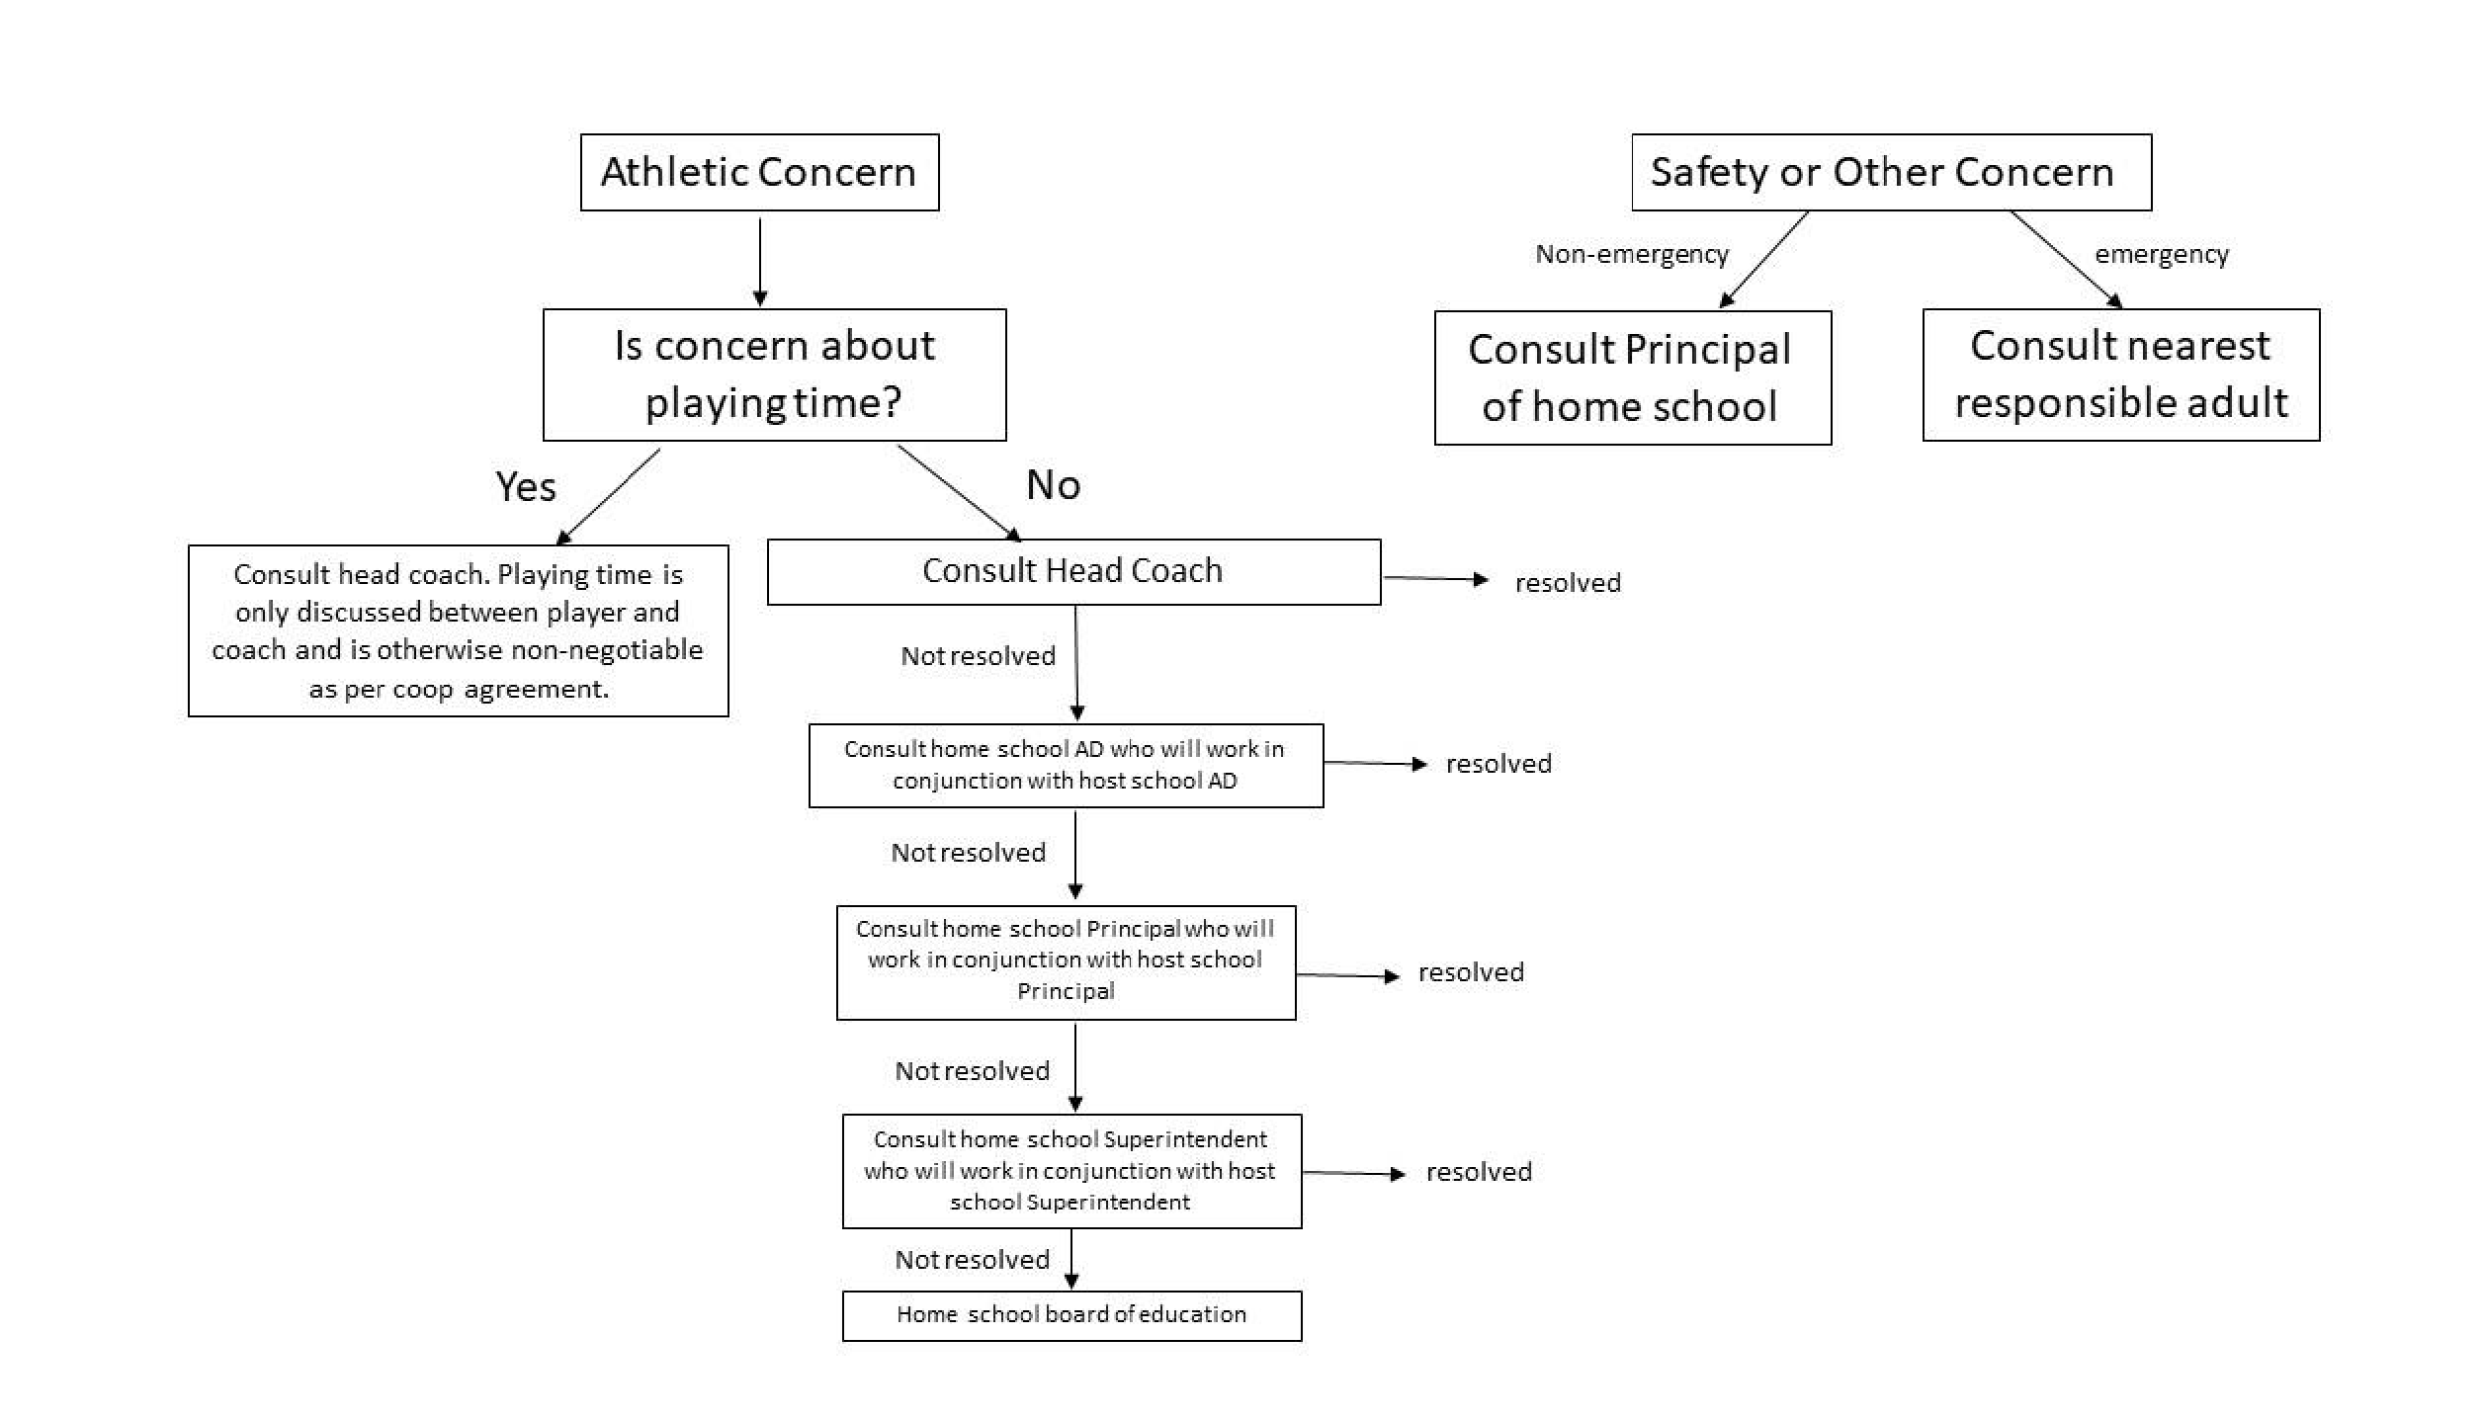

EXHIBIT B
WSS Parent Chain of Command
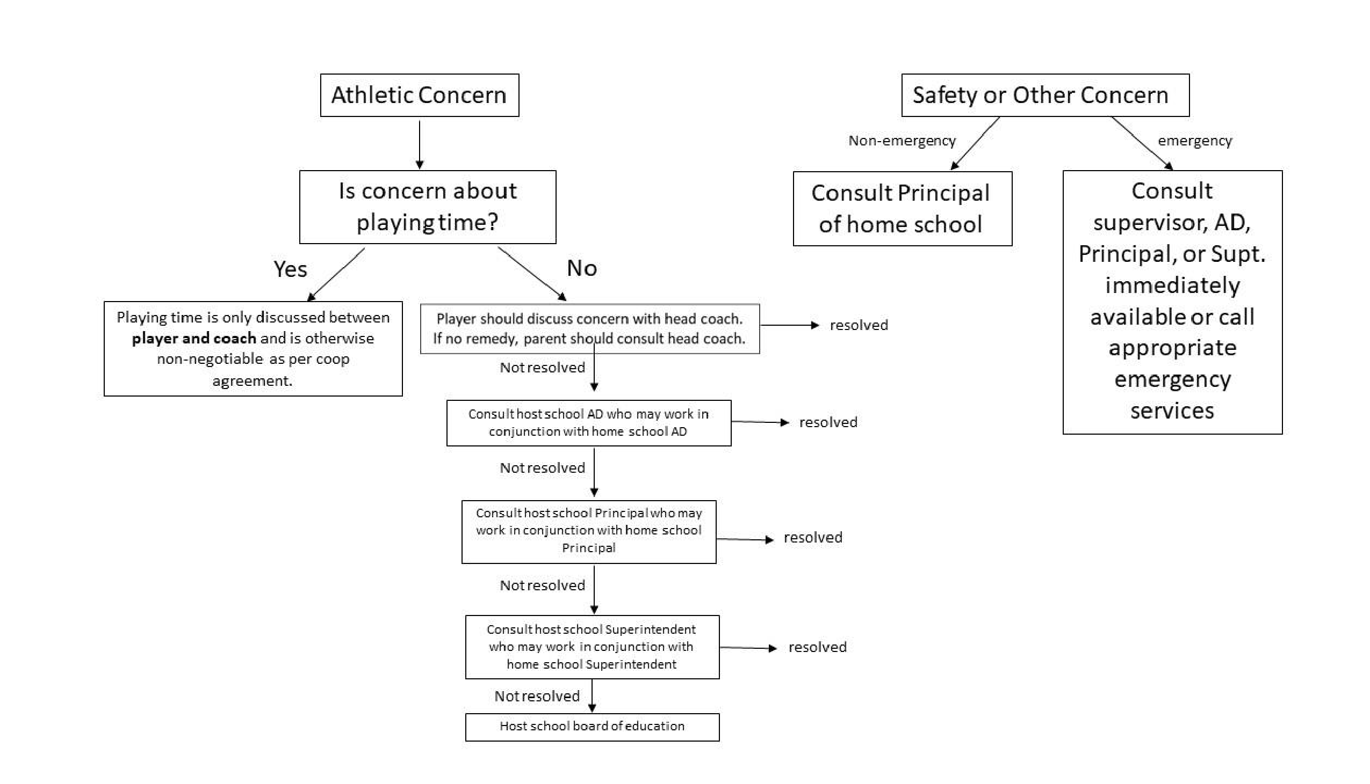

EXHIBIT C
WSS Coaches Chain of Command

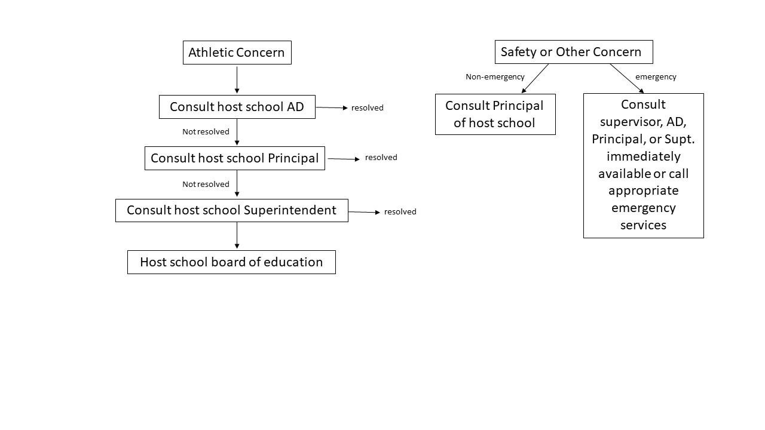

EXHIBIT D

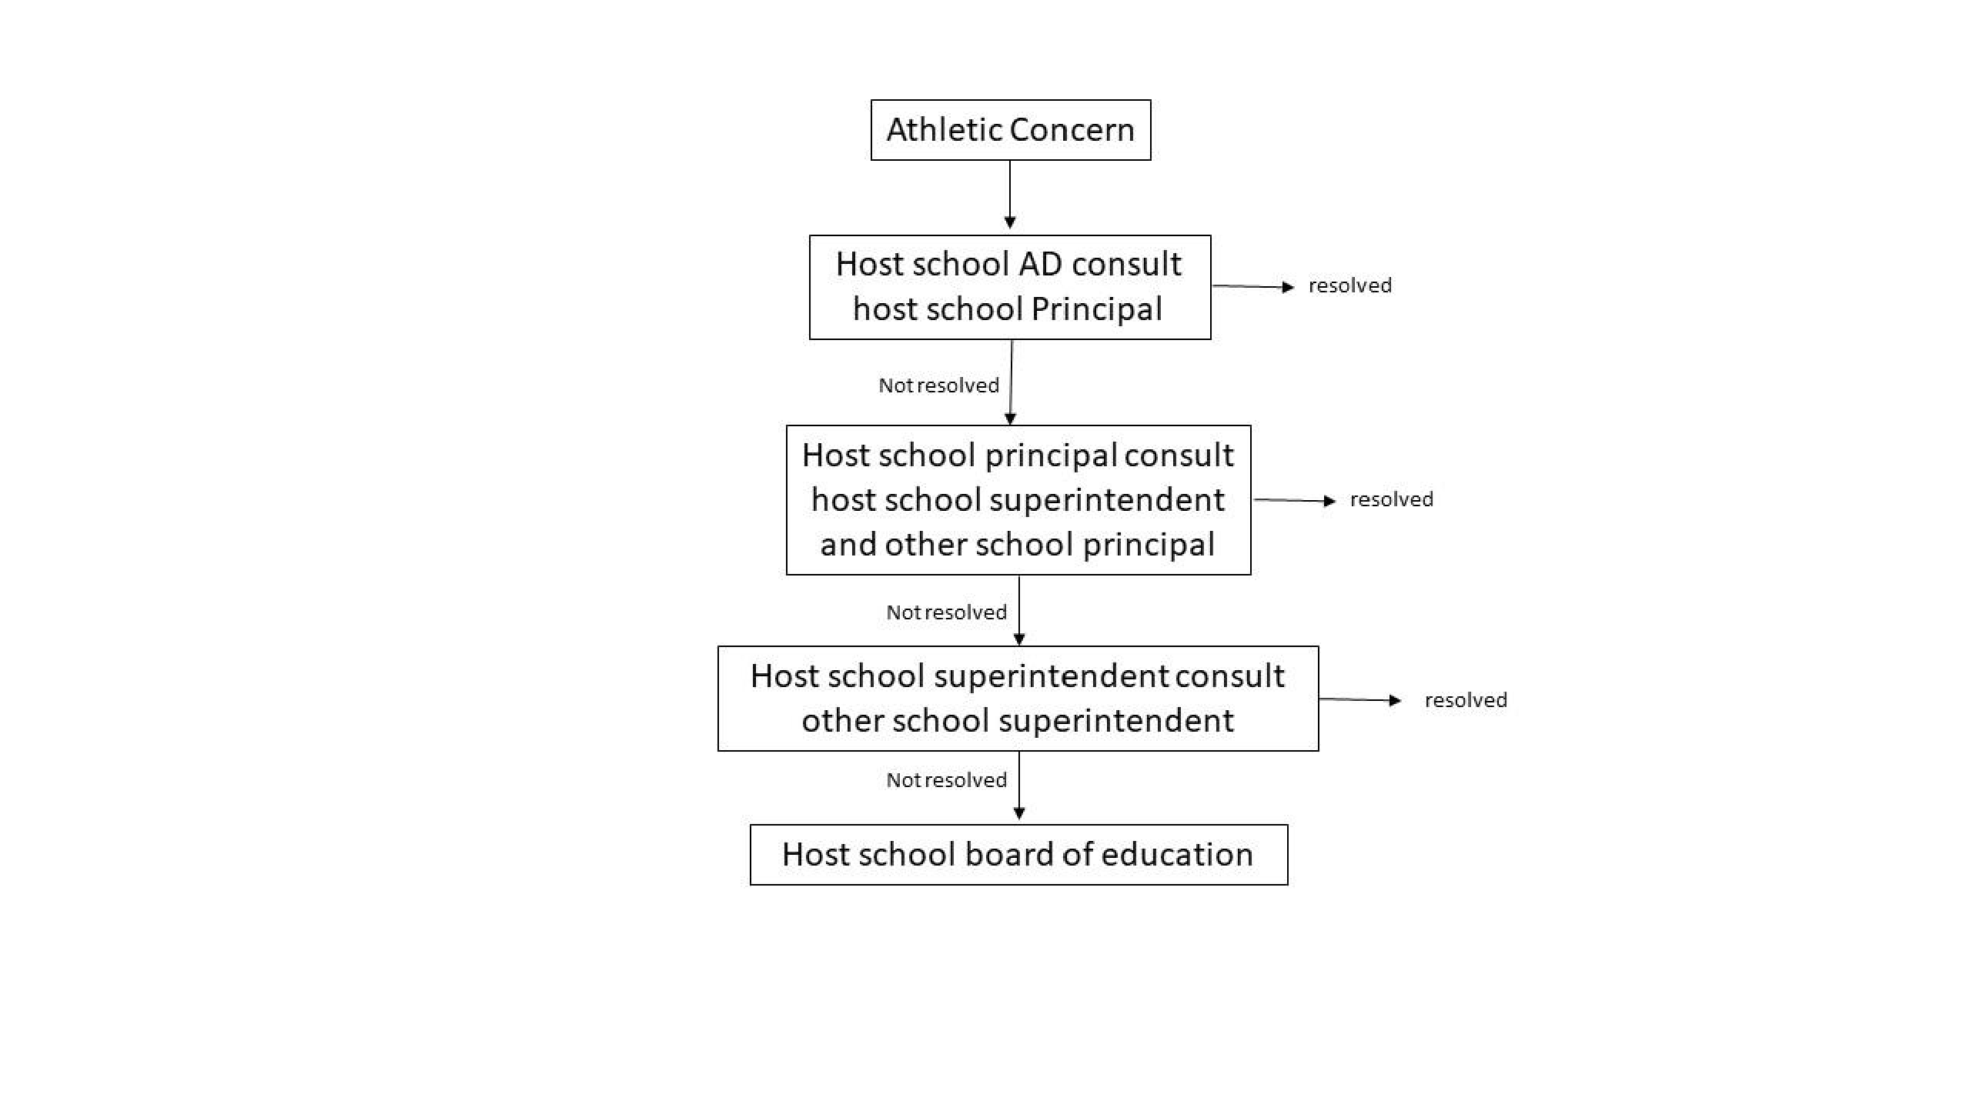
WSS Administration Chain of Command

EXHIBIT E
WSS Board of Education Chain of Command

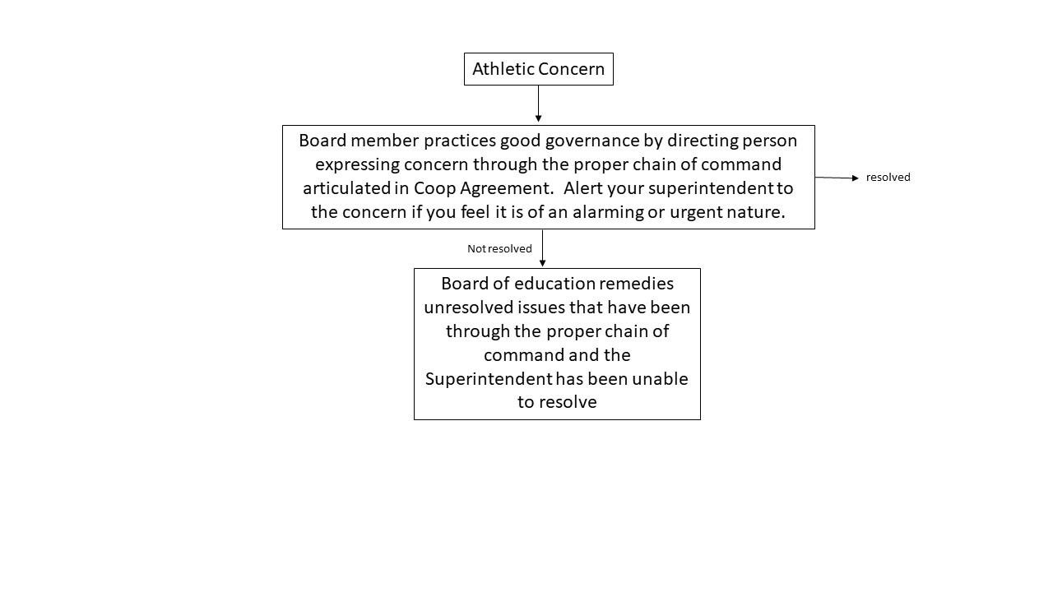

Exhibit F
Parent Communication

Athletic Director

Change of Event

Coach Contacted

BAND App

